Worth the Detour

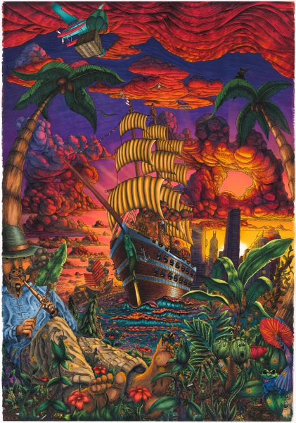 | Guttestreker  Systemica Epidemica, 2023  Signed front  Ink and markers on Arches 310g paper with archival UV varnish  39 3/8 x 27 1/2 in  100 x 70 cm  (G017) | $ 25,000
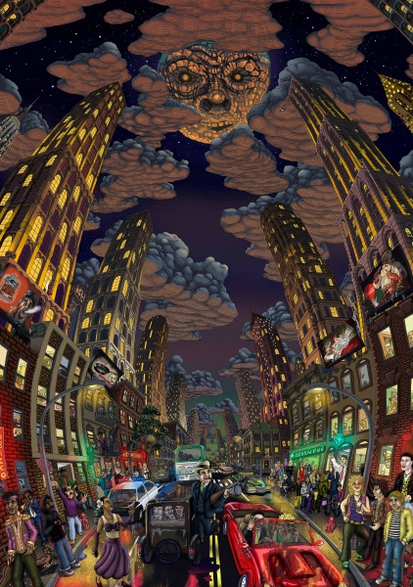 | Guttestreker  Substance City, 2023  Signed on verso  Tactile 40-layer UV ink print on aluminum  78 3/4 x 55 1/8 in  200 x 140 cm  4/15  (G014) | $ 8,000
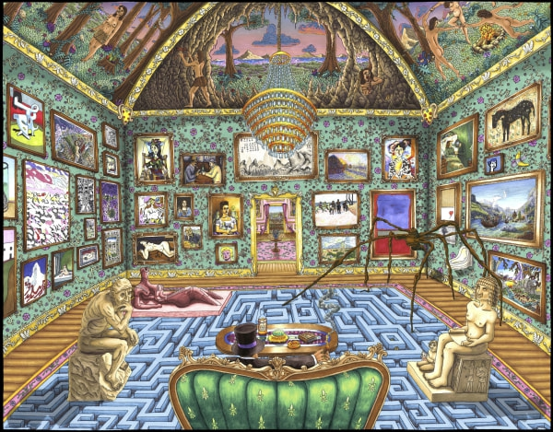 | Guttestreker  Medici Manor (Big), 2023  Signed front  Digital Graphic Art. Original lines by ink, scanned and colored by digital markers and printed by inkjet Epson Surecolor 9500 on Arches BFK 310g paper  53 1/8 x 41 3/8 in  135 x 105 cm  1/2 Artist's Edition PP  (G010) | $ 5,500
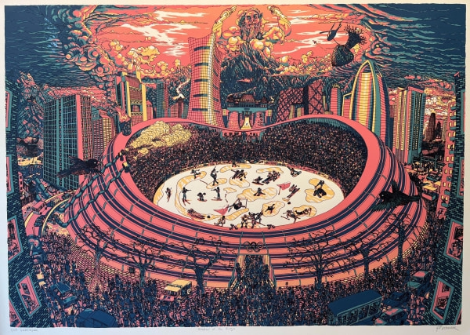 | Guttestreker  Shadow of the Rings, 2500  Signed front  Silk: 5-layer (colors) screen print on 400g Arches paper.  53 1/8 x 39 3/8 in  135 x 100 cm  25/45  (G009) | $ 4,500
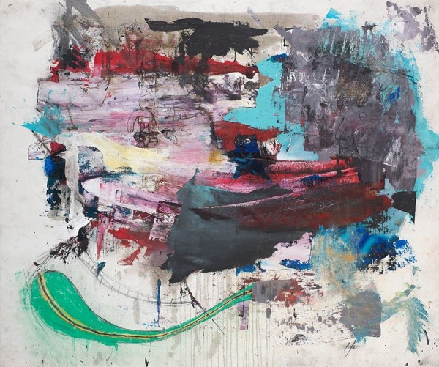 | Yunierki Felix Hodelin  Golden Fever, 2014  Signed front  Mixed media on canvas  45 x 54 inches  (YH6) | $ 13,500
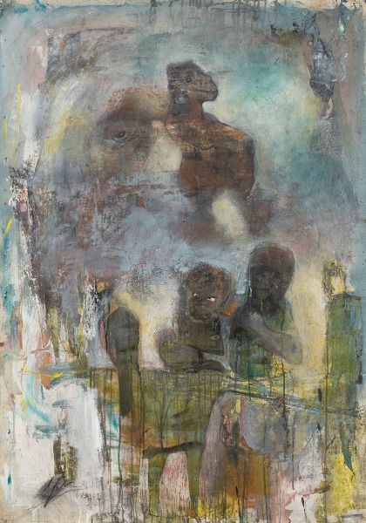 | Yunierki Felix Hodelin  Longing for the return, 2015  Signed front  Mixed media on canvas  53 x 38 inches  (YH25) | $ 13,500
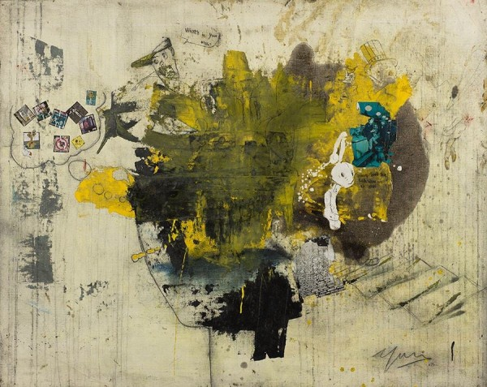 | Yunierki Felix Hodelin  Untitled, 2015  Signed front  Mixed media on canvas  43 x 53 inches  (YH18) | $ 13,500
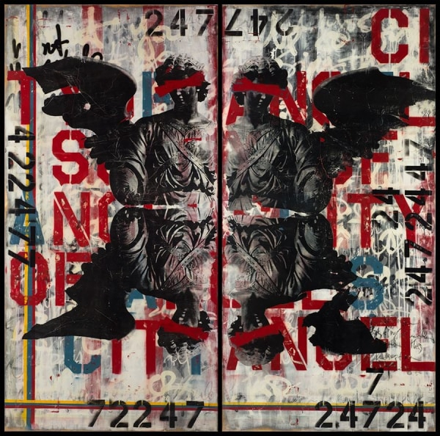 | Ashleigh Sumner  Redemption Song, 2014  Acrylic, Mixed Media, Resin on Panel  96 x 96 inches ;Diptych  (AS6) | $ 15,000
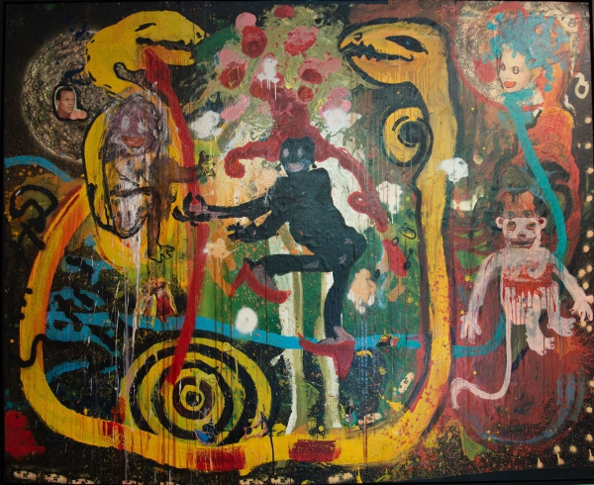 | James Andrew Brown  Miss Emily , 2002  Signed on Verso  Mixed Media and Oil on Roofing Felt  85 x 104  (JB197) | $ 45,000
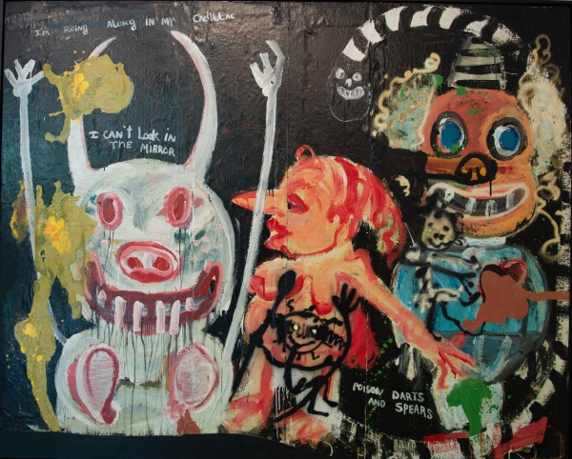 | James Andrew Brown  It was Hot Day in Georgia Went Jack Johnson Drove into Town, 2002  Signed on Verso  Mixed Media and Oil on Roofing Felt  82 x 102  (JB196) | $ 45,000
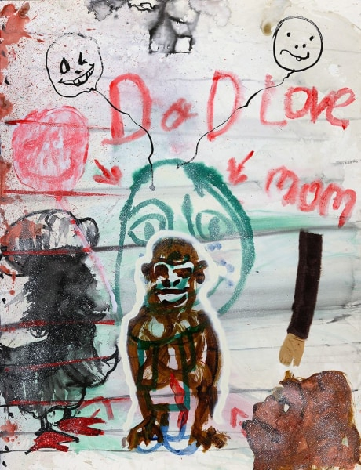 | James Andrew Brown  Dady Love Mom, 1998  Signed on verso  Mixed media on paper  50 x 38.5 inches  (JB74) | $ 4,900
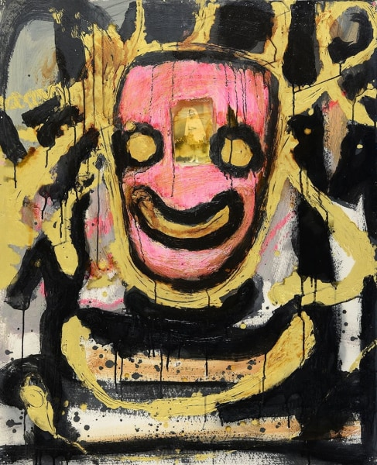 | James Andrew Brown  Free, 1990 - 1991  Signed on verso  Mixed media on hardboard  40 x 32 inches  (JB29) | $ 4,400
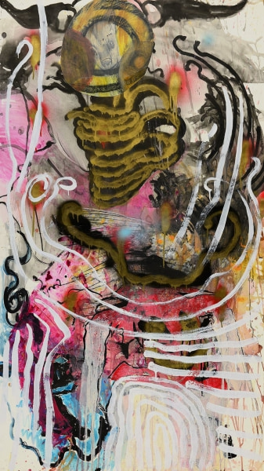 | James Andrew Brown  The Demon Running, 1996  Signed on verso  Mixed media on paper  59 x 33 inches  (JB56) | $ 4,900
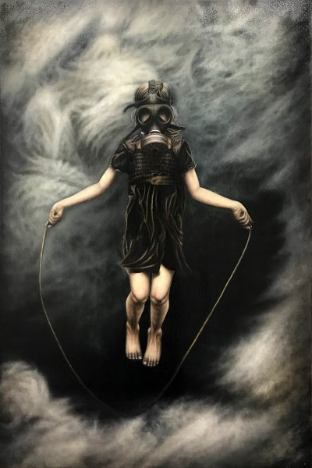 | Michael LaBua  Morning's Merriment, 2013  Signed on verso  Oil on linen  72 x 48 inches  (ML73) | $ 24,000
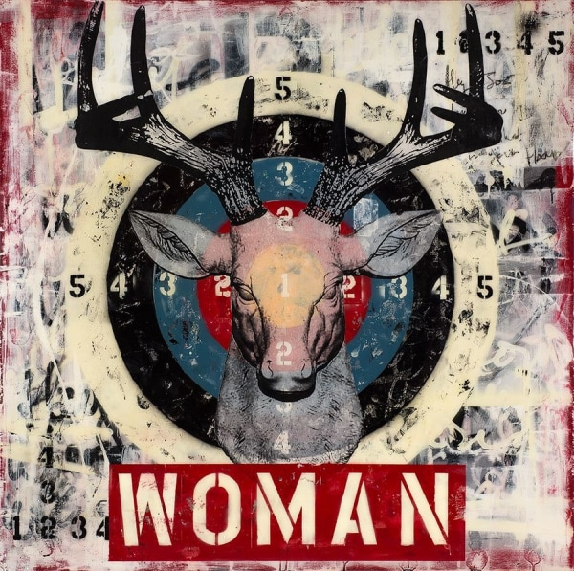 | Ashleigh Sumner  Hey Joe! Where Are You Going With That Gun In Your Hand, 2014  Mixed media; spray paint, silkscreen and ink on birch panel finished in torched resin  48 x 48 inches  (AS1) | $ 3,500
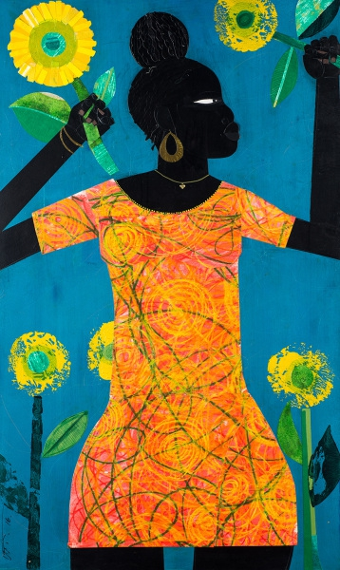 | Willie Torbert  Summer Brightest, 2016  Signed on verso  Mixed media on panel  40 x 24 inches  (WT38) | $ 4,400
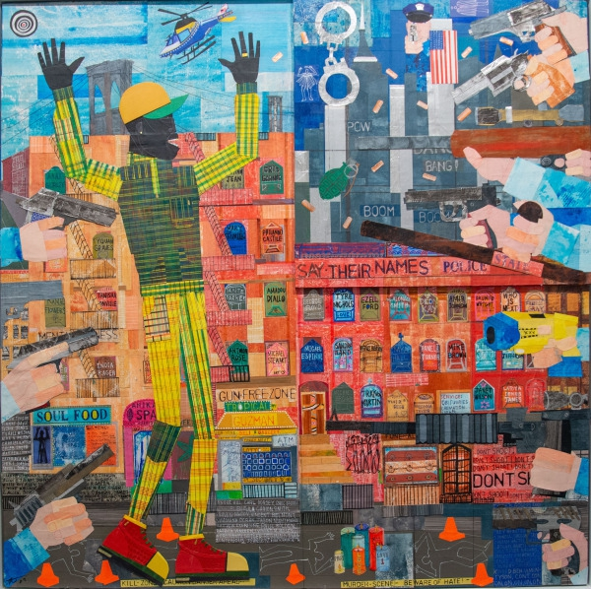 | Willie Torbert  Unnecessary Excessive Force , 2023  Signed on verso  Mixed Media on panel  51 x 51  (WT82) | $ 19,000
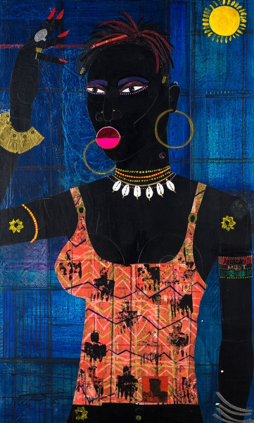 | Willie Torbert  HMU, 2015  Signed on verso  Mixed media on panel  40 x 24 inches  (WT41) | $ 4,400
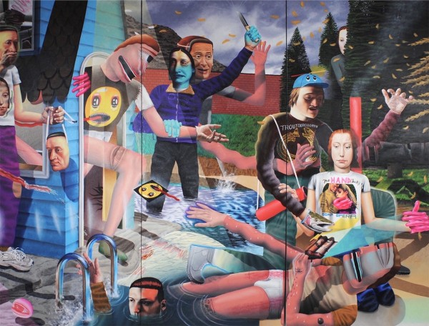 | Samual Weinberg  River-House Showdown, 2016  Signed front  Oil and acrylic on canvas  84 x 108 inches ;Triptych  (SW10) | $ 38,000
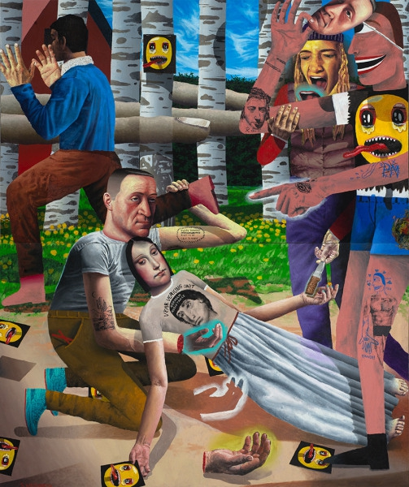 | Samual Weinberg  The Clearing or Sad Trippy Smilies, 2016  Signed front  Oil and acrylic on canvas  72 x 60 inches ; Diptych  (SW4) | $ 15,000
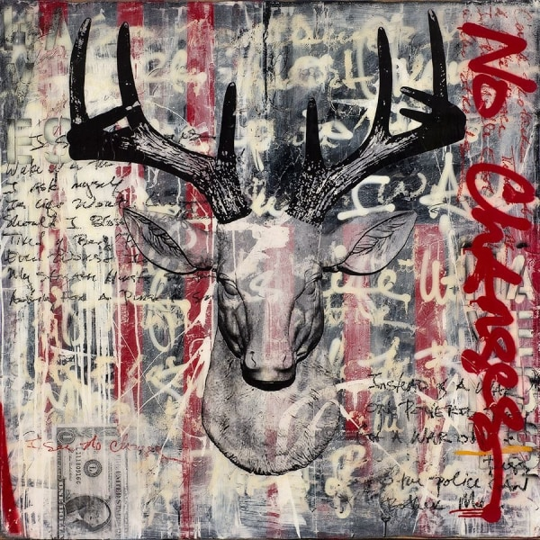 | Ashleigh Sumner  I See No Changes, 2014  Acrylic, Mixed Media, Resin on Panel  48 x 48 inches  (AS2) | $ 3,500
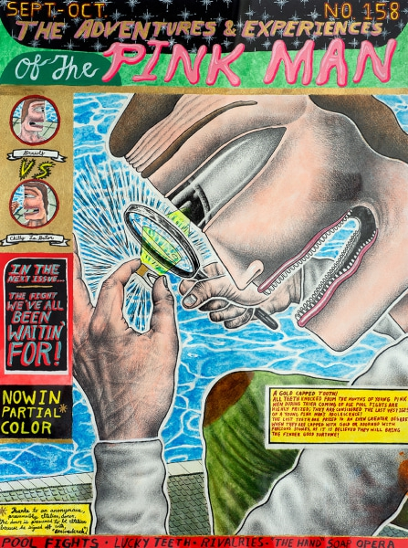 | Samual Weinberg  The Adventures & Experiences of The Pink Man (No. 158), 2017  Mixed media on watercolor paper  24 x 18 inches  (SW7) | $ 2,850
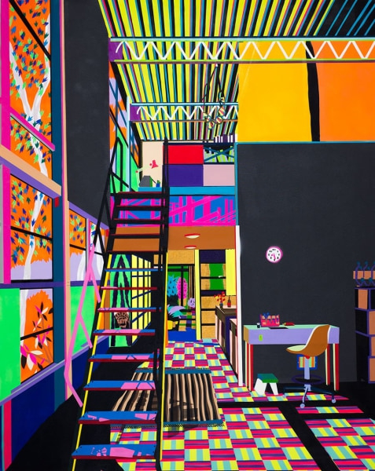 | Michael Callas  Untitled (Case Study), 2013  Signed on verso  Aerosol on canvas  75 x 60 inches  (MC23) | $ 12,500
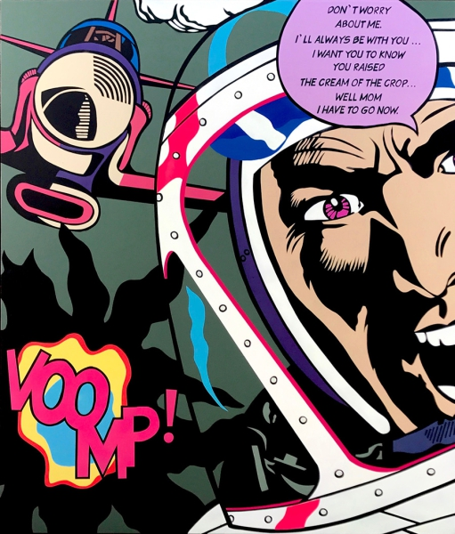 | Michael Callas  The Intrepid Son, 2017  Signed on verso  Aerosol on canvas  92.125 x 77.75 x 2.5 inches  (MC36) | $ 19,000
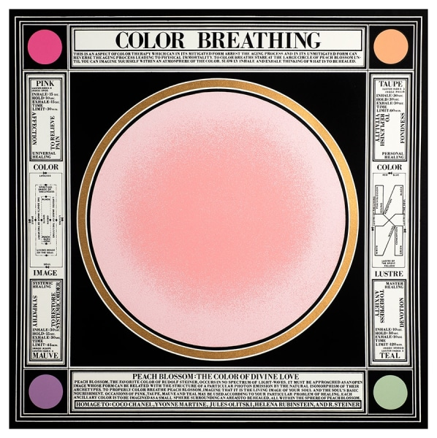 | Paul Laffoley  Color Breathing, 1983  Signed lower right; Paul Laffoley  Silkscreen on rag paper  Image: 23 x 23 inches  Framed: 29.5 x 29.5 inches  PP, Edition 17 of 18 (TP 1/1)  (PL3) | $ 4,000
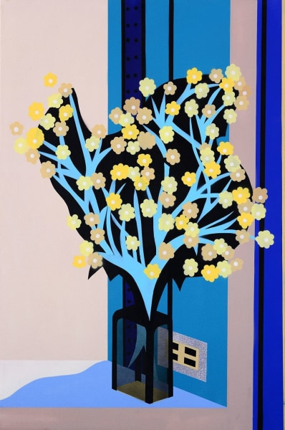 | Michael Callas  Flower Study, 2013  Signed on verso  Aerosol on canvas  36 x 24 inches  (MC8) | $ 2,500
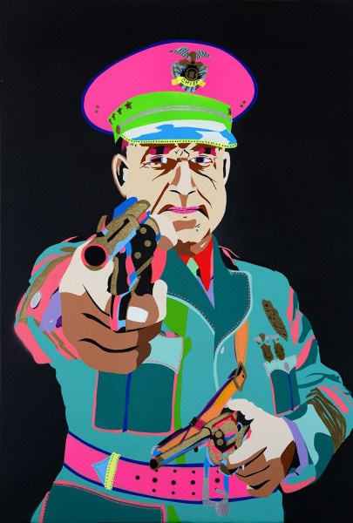 | Michael Callas  Chief, 2013  Signed on verso  Oil on canvas  40 x 27 inches  (MC2) | $ 2,500
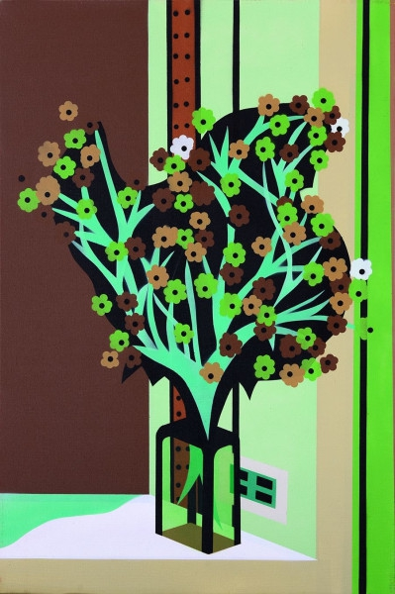 | Michael Callas  Flower Study, 2013  Signed on verso  Aerosol on canvas  36 x 24 inches  (MC7) | $ 2,500
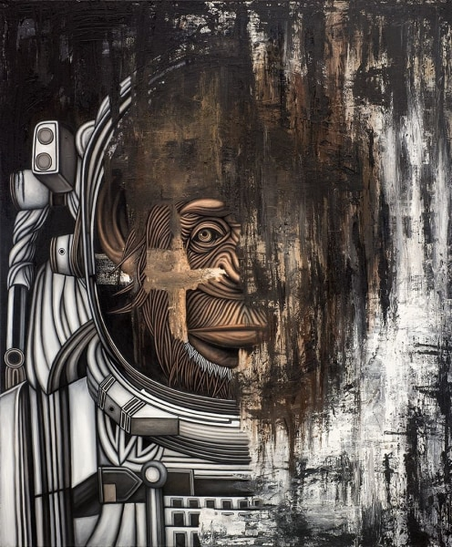 | Michael LaBua  Evolyutsiya, 2015  Signed on verso  Oil on linen  66 x 54 x 2.5 inches  (ML39) | $ 24,000
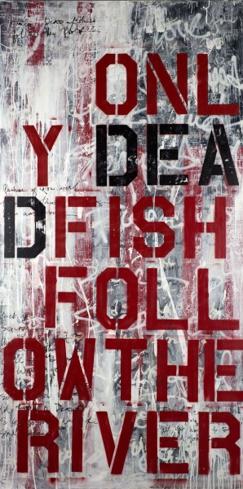 | Ashleigh Sumner  Only Dead Fish Follow The River, 2014  Acrylic, Mixed Media, Resin on Panel  96 x 48 inches  (AS7) | $ 6,500
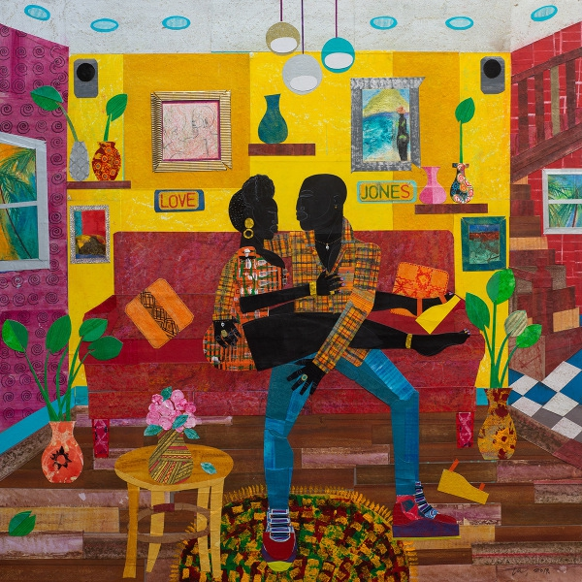 | Willie Torbert  Love Jones - Our Love Runs Deep, 2019  signed on the front and on the verso  Mixed media and collage on panel  48 x 48 inches  (WT60) | $ 16,000
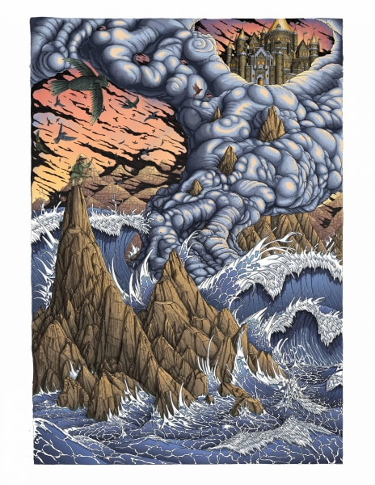 | Guttestreker  Recipe for Immortality, 2021  Signed on verso  1 or 2-layer UV ink on aluminum  70 7/8 x 49 1/4 in  180 x 125 cm  8/15  (G008) | $ 5,000

